Operational Concept Description (OCD)

ThrdPlace Social Networking

Team #7

Team members | Role
Gaurav Doon | Project Manager
Yixiang Liu | Developer
Tu Duong | IV&V
Ronghui Zhang | Tester
Kan Qi | Developer

04/47/2014

Version History
Date | Author | Version | Changes made | Rationale
09/22/13 | Yixiang Liu | 1.0 | - Finished the instruction of OCD  - Added the Shared Version  - Finished the instruction of the current system | - To reorganize the operational concepts of the current system and give a clear understanding for Team #7.
09/26/13 | Yixang Liu | 1.1 | - Update the Shared Version after the win-win negotiation  - Fix some mistakes in version1.0 | - To update the information from the clients
10/09/13 | Yixiang Liu | 2.0 | - Add the system objectives, constraints and priorities  - Fix some mistakes in version 1.1 | - To determine the objectives, constrains and priorities of the system.
10/13/13 | Yixiang Liu | 3.0 | - Finish the whole part of the OCD | - To determine the new operation conceptions, organizational and operational implications
11/30/13 | Yixiang Liu | 3.1 | - Update result chain and fix some and new workflows  - Fix some mistakes in version 3.0 | - To update the data from clients and operational concept analysis. And refine the document
11/30/13 | Yixiang Liu | 3.2 | - Fix some mistakes in version 3.1 | - To update the nouns and conception of the system after the team meeting and commitment.
11/30/13 | Yixiang Liu | 4.0 | - Revise the shared vision, system boundary, workflow, OC, OG. | - To revise some parts of the OCD after the ARB session and update some information got from clients after meeting.
11/23/13 | Yixiang Liu | 4.1 | - Revise the win-condition | - To update the change of win-conditions from clients.
04/27/14 | Yixiang Liu | 4.2 | - Fix some mistakes | - Fix some mistakes in document.

Table of Contents
Operational Concept Description (OCD) i
Version History ii
Table of Contents iii
Table of Tables iv
Table of Figures v
1. Introduction 1
1.1 Purpose of the OCD 1
1.2 Status of the OCD 1
2. Shared Vision 2
2.1 Benefits Chain 3
2.2 System Capability Description 3
2.3 System Boundary and Environment 4
3. System Transformation 5
3.1 Information on Current System 5
3.2 System Objectives, Constraints and Priorities 8
3.3 Proposed New Operational Concept 10
3.4 Organizational and Operational Implications 13

Table of Tables
Table 1: The Program Model 2
Table 2: The Infrastructure 5
Table 3: Capability Goals 8
Table 4: Level of Service Goals 8
Table 5: Relation to Current System 9

Table of Figures
Figure 1: Benefits Chain Diagram of ThrdPlace Social Networking 3
Figure 2: System Boundary and Environment Diagram of ThrdPlace Social Networking 4
Figure 3: Business Workflow Diagram of ThrdPlace – Implement a project 6
Figure 4 Business Workflow Diagram of ThrdPlace –contribute to a project 7
Figure 5: Element Relationship Diagram of ThrdPlace 10
Figure 6: Business Workflow Diagram of ThrdPlace-Implement a project 11
Figure 7: Business Workflow Diagram of ThrdPlace- Contribute to a project 12

Introduction

Purpose of the OCD
The OCD document is to identify the stakeholders’ shared version and the information of the current system in details. In this project, the improvement of the ThrdPlace social Networking, we define the project contributors and project creators on ThrdPlace as users; members of team #7 as developers; the team of ThrdPlace as maintainers; and Michael Colomiso and Dekoven Ashley, the owner of ThrdPlace, as main clients of the project.

Status of the OCD
This is the OCD documents for the ThrdPlace Social Networking project at the version 4.1, which is also the final version of OCD. Previous versions have settled down the shared version, system objectives, constraints and priorities as well as the organizational and operational implications. In the version, we revise the shared vision and system boundary, refine some workflows and operational conceptions of the project, fix some mistakes and fill in some blank information from formal versions.

Shared Vision
Thrdplace.com (“thrdPlace”) is a venue for fund-raising, resource sharing and commerce. thrdPlace allows certain users (“Project Creators”) to list projects and raise funds, labor and supplies from other users (“Project Contributors”)
Table 1: The Program Model
Assumptions:
1) Project contributors and project creators need a recommendation system to increase their reach.
2) Project contributors and project creators want to search information they need more easily and conveniently.
3) Project creators are willing to pay the transaction fees.
Stakeholders | Initiatives | Value Propositions | Beneficiaries
- Developers  - Project contributors on ThrdPlace  - Project creators on ThrdPlace  - ThrdPlace | - Develop search system and recommendation system.  - Provide recommended projects  - Provide recommended contributors  - Promote ThrdPlace platform. | - Increased reach of project creators and contributors.  - Increased use of ThrdPlace platform  - Increased revenue of ThrdPlace. | - Project contributors on ThrdPlace  - Project creators on ThrdPlace  - ThrdPlace

Benefits Chain
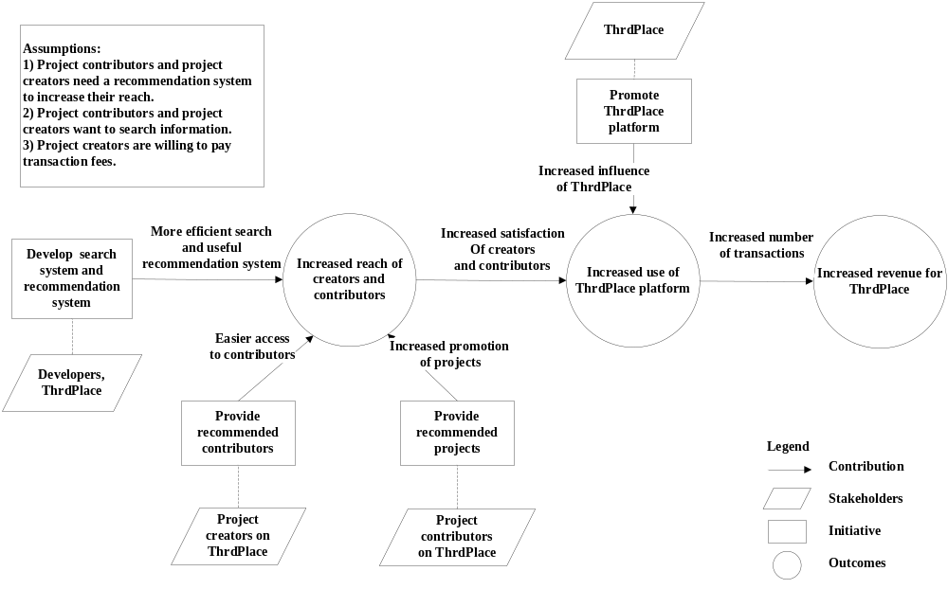
Figure 1: Benefits Chain Diagram of ThrdPlace Social Networking

System Capability Description
- The current website has already provided a map system to help project contributors to discover projects in local community or other places.
- The primary goal of the ThrdPlace is to add a new search engine with ranking and recommendation system to the current website.
- The search engine is used to search projects, creators or contributors.
- The aim of the recommendation system is to help project creators to find potential project contributors and help contributors to find potential projects.
- The aim of the ranking system is to sort the search results by influence.

System Boundary and Environment

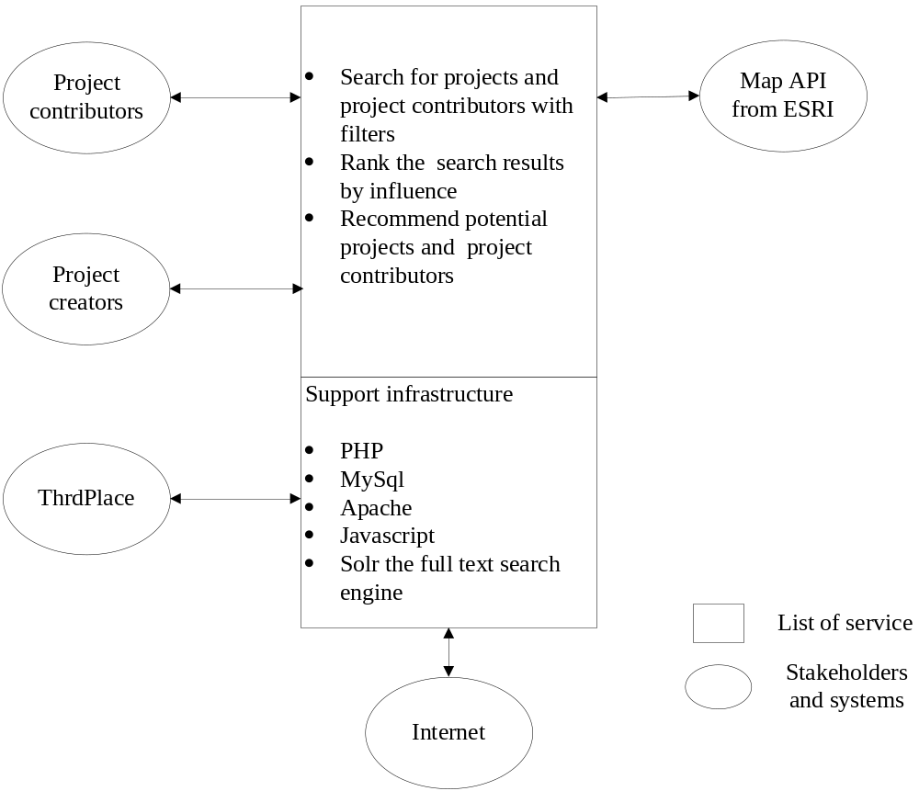
Figure 2: System Boundary and Environment Diagram of ThrdPlace Social Networking

System Transformation

Information on Current System

Infrastructure
The ThrdPlace has a website (URL:http://www.thrdplace.com) and the website has been put into use since fall 2012. The website has been deployed on a Linux server. The whole website is developed by PHP and HTML5 and the team use MySql to manage the database.
Table 2: The Infrastructure
Hardware | - Several personal computers for development.  - A server runs in UNIX system.
Software | - PHP  - MySQL database system  - Apache  - Microsoft office package  - Javascript  - Ajax  - Map interface API from ESRI
Development Platform | - Microsoft Windows  - Mac OS

Artifacts
- Website Wireframes: The wireframes of ThrdPlace are used as a visual guide that represents the skeletal framework of a website.
- UserFlows: The userflows document is used to specify the user stories and scenarios
- Code Track: The ThrdPlace has the track of the developed code files of the website.

Current Business Workflow
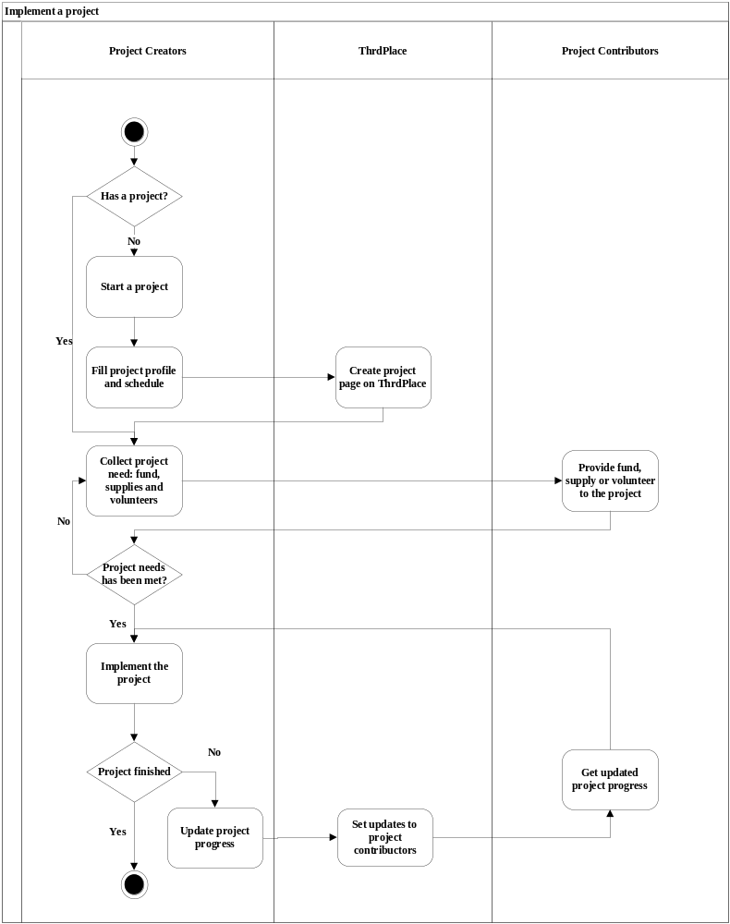
Figure 3: Business Workflow Diagram of ThrdPlace – Implement a project
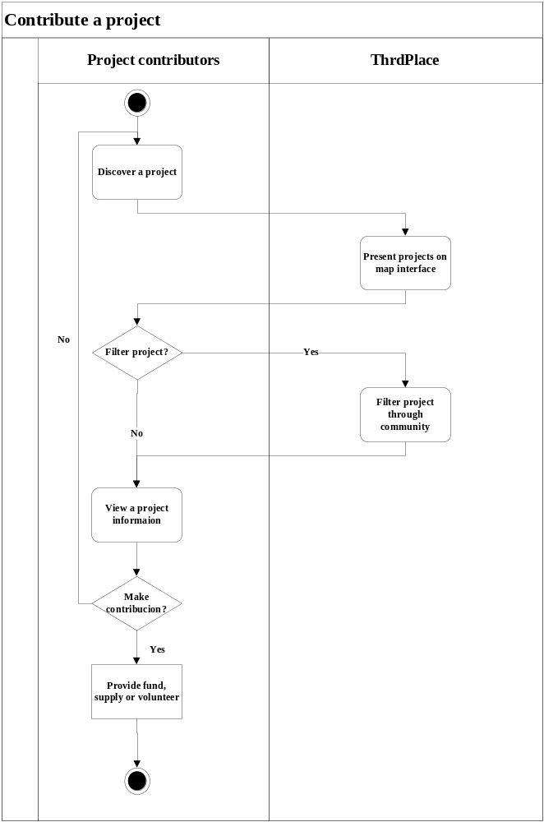
Figure 4 Business Workflow Diagram of ThrdPlace –contribute to a project

System Objectives, Constraints and Priorities
After the second win-win negotiation, the objectives, constraints and priorities has been a. The mainly capability goals contains a search engineer for projects and project contributors with a ranking system of influence and a recommendation system to recommend projects and contributors.

Capability Goals
Table 3: Capability Goals
Capability Goals | Priority Level
OC-1 Search projects and contributors: The system is capable of enabling project contributors to search projects and project creators to search contributors with filter. Besides, it’s capable of displaying the search results in a list view. Also, it’s capable of enabling project contributors and project creators to search the most influential projects and project contributors. | <<Must have>>
OC-2 Ranking search results: The system is capable of providing a ranking system to rank the search results by influence. The criterion of the influence includes promotion, the completion percentage of the project and the contribution of contributors. | <<Must have>>
OC-3 Recommend projects and contributors: The system is capable of providing useful suggestions about projects and contributors. For the project creators, it’ll recommend contributors interested in the project; for the contributors, it’ll recommend influential projects. | <<Must have>>

Level of Service Goals
Table 4: Level of Service Goals
Level of Service Goals | Priority Level | Referred WinWin Agreements
Max downtime is 3days in a month. | <<Must have>> | LOS-1

Organizational Goals

OG-: Increase revenue of ThrdPlace.
OG-2: Increase reach of project creator and contributors.
OG-3: Increase use of ThrdPlace platform

Constraints
CO-1: Max downtime: The max downtime of the ThrdPlace is 3 days in a month.
CO-2: Max Budget: The max budget of the system is 10,000 dollars.
CO-3: Deployment: The new system will be deployed on ThrdPlace Server.

Relation to Current System
Table 5: Relation to Current System
Capabilities | Current System | New System
Roles and Responsibilities | Project creators can start new projects and project contributors can join active projects. | The roles and responsibilities will not change in the new system.
User Interactions | Creators have a homepage page for project and contributors can visit the page. | Creators and contributors can search, get recommendation and measure influence.
Infrastructure | Project homepage with project profile. | Includes search, ranking and recommendation system.
Stakeholder Essentials and Amenities | The system only provides limited information about projects. | The system greatly improves the management of projects and contributions.
Future Capabilities | Time-consuming for creators and contributors to find potential resources. | Provides efficient search, useful recommendation, and accurate measure of influence.

Proposed New Operational Concept

Element Relationship Diagram
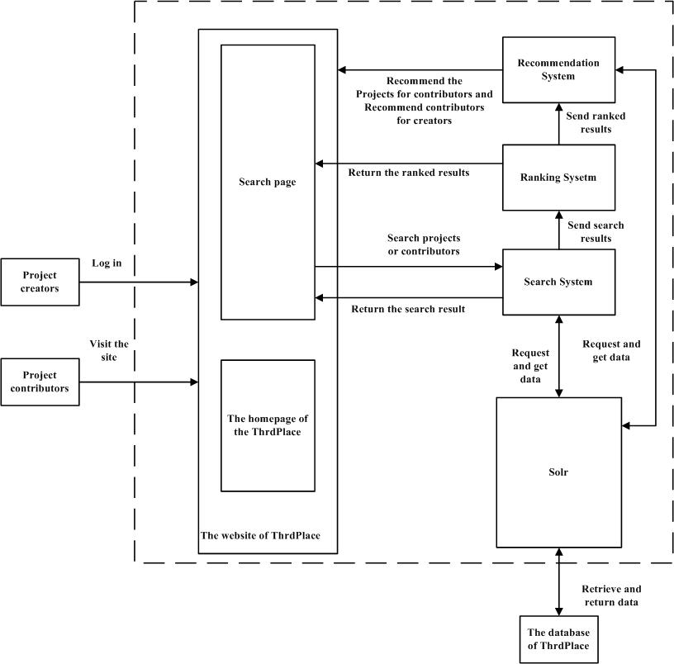
Figure 5: Element Relationship Diagram of ThrdPlace

Business Workflows
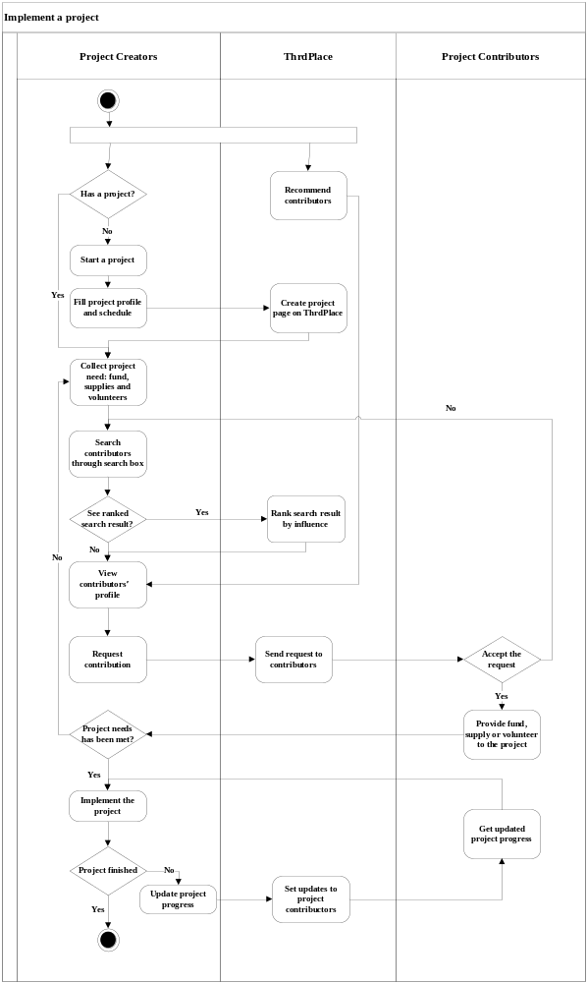
Figure 6: Business Workflow Diagram of ThrdPlace-Implement a project
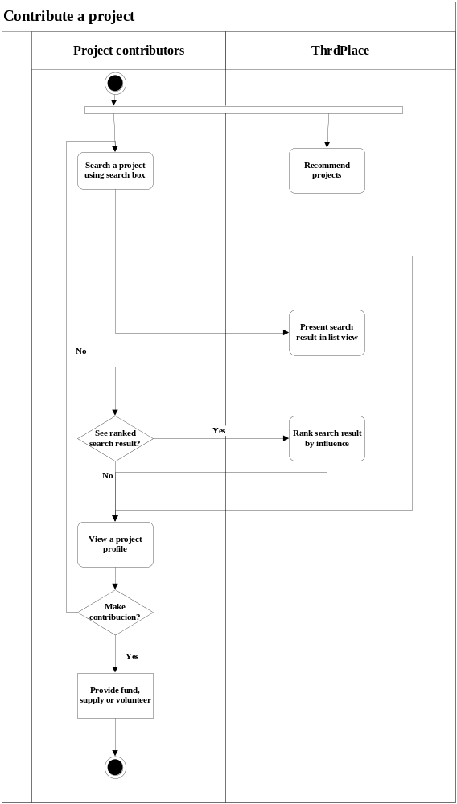
Figure 7: Business Workflow Diagram of ThrdPlace- Contribute to a project

Organizational and Operational Implications

Organizational Transformations
- The need for developers to pay more attention on protecting privacy of project contributors and project creators.
- The need to hire a high-level DBA(Database Administrator) to manage a more complex and large-scale database.

Operational Transformations
- Having the recommendation system rather than manually discovering resources to reduce management time of projects and contributions.
- The option for project creators and contributors to measure their influence through ranking system, or to use their own methods.

